

Search

David Murphy

09 August [Development](https://messapps.com/tag/development/)

**iOS App Development: Submitting an Update**

**Learn how to submit your app's latest version for review!**

Sign in to [***iTunes Connect***](https://itunesconnect.apple.com/itc/static/login?appIdKey=e0b80c3bf78523bfe80974d320935bfa30add02e1bff88ec2166c6bd5a706c42&amp;view=1&amp;path=%2FWebObjects%2FiTunesConnect.woa%3F) with your [***Developer account***](https://messapps.com/creating-your-first-ios-developer-account/) and click **My Apps** on the main iTunes Connect dashboard; find and select the app to be updated

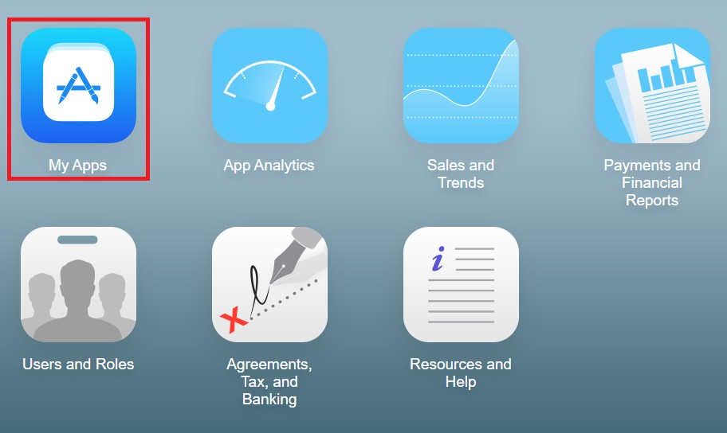

***NOTE*** Only users with an Admin, Technical, or App Manager role can add a new app version. Also, all certifications must be up­to­ date before Apple will apply any changes to your app.

If you see a caution similar to the one in the image below, then you might need to sign­in and address the issue first with a user that has a higher **Role** in your iTunes Connect dev team

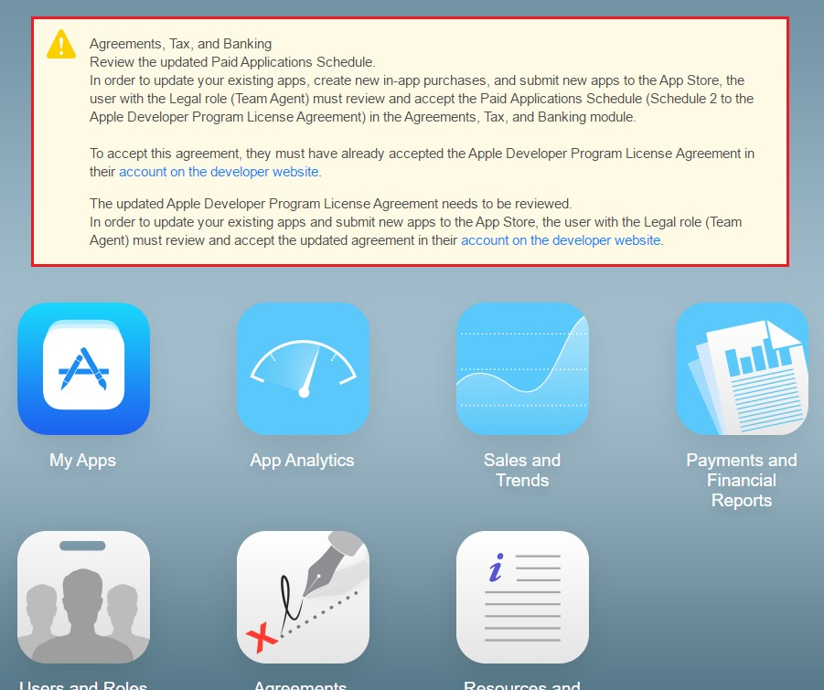



Another prerequisite to the updating process is that the app in question must already be deemed **Ready for Sale** by Apple before a new build can be added

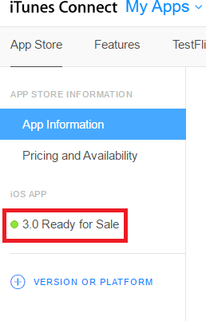

Now select**+ VERSION OR PLATFORM** below **Ready for Sale** and select **iOS**

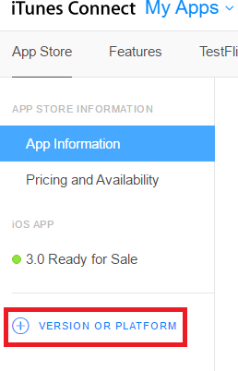

Enter the new version number and hit **Create**

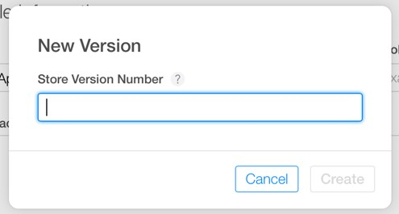

After hitting **Create,** notice how only those properties that may be changed are editable. When updating a build, all information is automatically carried over onto your store's page *except* for its description and screenshots. This is because Apple wants all amendments made to an app to be reflected whenever changes are made

If necessary, make sure you’ve made all changes the **Build** of your app by clicking **Ready for Sale** and locating and selecting the new **Build.**

Before submitting your app for review, you're given the option to **Manually** update your new version onto the app store after it passes the review process

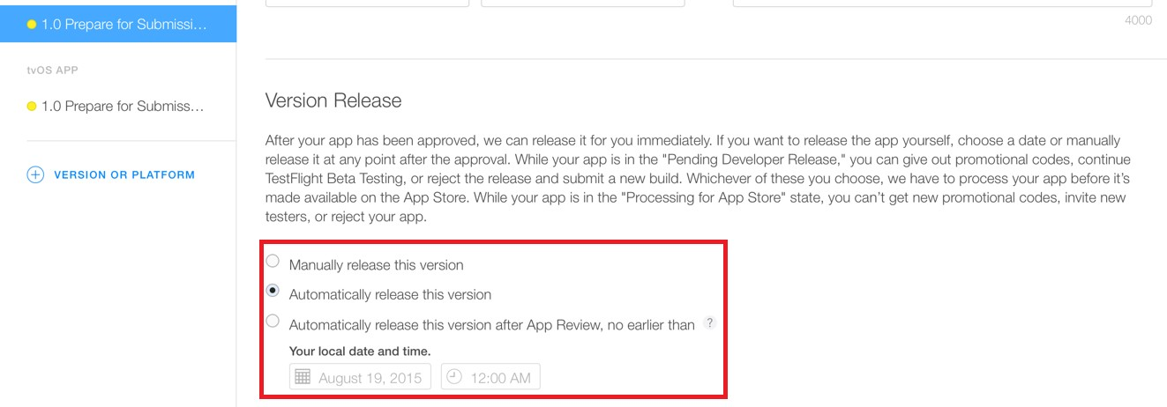

The **Automatic** options are self­explanatory; however, if you choose **Manually release this version,** then your app’s status will change to **Pending Developer Release** once it receives approval for release from Apple. Choosing this could take up to 24 hours to process

Now locate and click the **Save** and **Submit for Review** buttons at the top­right corner of your **iTunes Connect** page ­ that’s all there is to it!

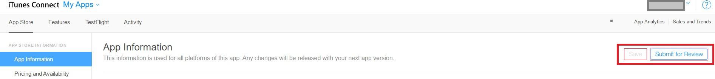

0

You might also like this articles

Dominick Wojtas



25 November

# [Keep Your App Relevant](https://messapps.com/academy/articles/keep-app-relevant/)

An average iOS phone is said to have 48 apps downloaded in the United States. This means marketing for your app doesn’t end at the download. Keep your users coming back by keeping your app relevant and up to date with trending themes, features and other attractive app elements.

0

Dominick Wojtas

12 October

# [Putting your idea on paper](https://messapps.com/academy/articles/putting-idea-paper/)

Maybe you finally found a solution to a widespread problem. Maybe you were inspired by something you saw on the street, or at work. Maybe you just had a moment of creativity in the shower. No matter what your idea is and how good it sounds in your head, it’s time to put it on paper.

0